Ann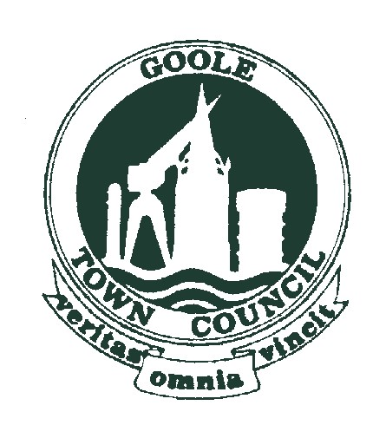ual Town Meeting


Annual Town Meeting
Under the Local Government Act 1972 s9 all parishes/towns in England must hold an Annual Parish/Town Meeting. This is an annual statutory public meeting of the Town’s electors and is therefore not used to address standard Council business.
The Annual Town meeting follows a legal requirement for town and parish councils to hold an electors meeting, once a year to raise any issues of their choice.
Section 9 of the Local Government Act 1972 states that “for every parish there shall be a parish meeting for the purpose of discussing parish affairs and exercising any functions conferred on such meetings by any enactment…”
Section 13 of the Act states that “the parish meeting of a parish shall consist of the local government electors for the parish”.
The 1972 Local Government Act therefore requires every town and parish council to host a meeting between March and June each year, to which all their electors are invited.
Goole Town Council’s meeting will be held at Junction on 8th May, 2025 commencing on conclusion of the Council’s AGM
If you would like any issues to be discussed at the meeting, please forward them to the Town Clerk Brian.Robertson@goole-tc.gov.uk no later than 1st May, 2025

B Robertson
Town Clerk

